HOW TO SET UP
YOUR EDUBLOG
This assignment is designed to get you started in DL 10.
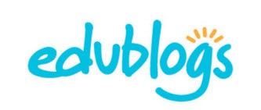
The blog is an essential piece to sharing your learning publicly.
D
I
G
I
T
A
L

L
E
A
R
N
I
N
G

1
0
s
t
e
p

1

|

a
c
c
e
s
s
i
n
g

y
o
u
r

E
d
u
b
l
o
g

a
c
c
o
u
n
t

s
t
e
p

3

|

y
o
u
r

f
i
r
s
t

p
a
g
e

Follow the instructions in the on your About Me page, please
Edublogs manual to access your introduce yourself. Please only share account what you feel comfortable sharing and all information should be non-
identifiable to you.

step 2 | customization  You can leave the theme set to plane and skip to step 3  OR  you can select another theme customize your theme change the header | 1 paragraph - 3-5 sentences  step 4 | your first blogposts  Create 1 blog post for the following (3 blog posts total):  1. youtube clip
****please ensure that we can see your 2. image with impact
^{menu} 3. a quote that means something to you

/Mehai, Nagra, Valente 2019

Assessment
Name: _________________ Homeroom #: _____________
In this task, you will be creating original content on your new blog!
Deadline: October 18, 2019

Please do your self assessment (next page) and submit it in the Digital Learning 10 basket in the Main Office.

Tag your new posts as assignment1

The fluencies we will be assessing are Media and Creativity:

Media - Be able to interpret and analyze media in order to both decode messages and create original content.

Creativity - Identify problems, develop and generate ideas in new and imaginative ways to demonstrate learning.

How we will be assessing your final product:
Select the appropriate media sources to maximize effectiveness and efficiency. How effective was the video, image and quotation you chose in showing us who you are? Did you add creative commons media? Did you cite your sources (link)?

Understand and implement principles of design to improve visual presentation. Were you thoughtful in considering aspects of design when it comes to your page and three posts?

Curate a digital blog to express personal views and perspectives of yourself. Did you express your thoughts fully, and write at least one paragraph (3-5 sentences)? Did you provide insight as to why the posts are meaningful for you?
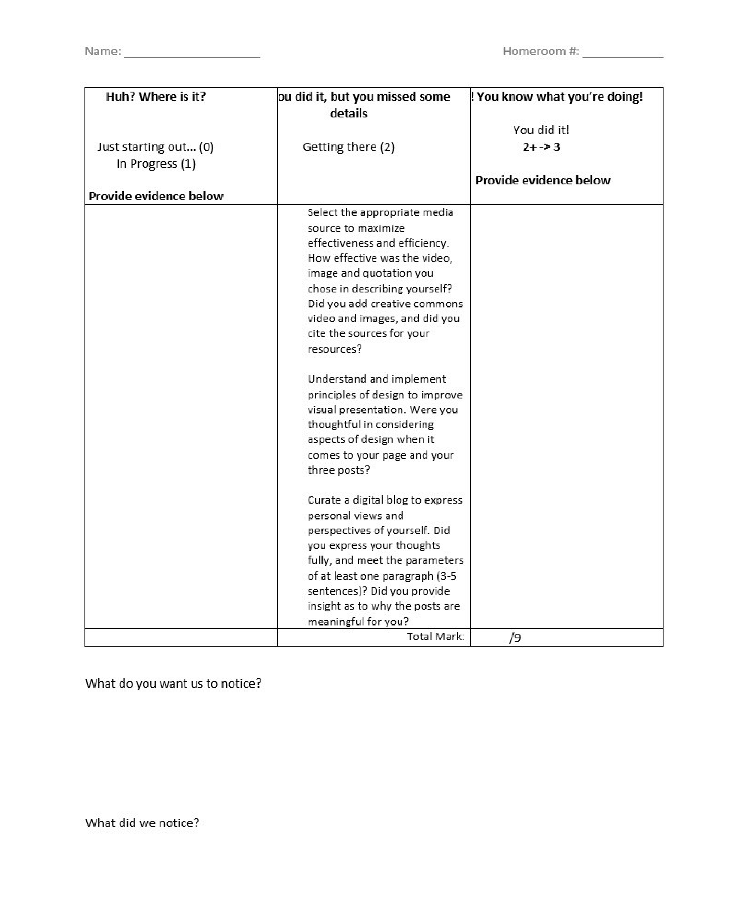
R
u
b
r
i
c
Y
o
u

d
i
d

i
t
,

b
u
t

s
o
m
e

e
l
e
m
e
n
t
s

a
r
e

m
i
s
s
i
n
g

s
o
m
e

d
e
t
a
i
l
s
.

G
e
t
t
i
n
g

t
h
e
r
e

(
2
)

Y
o
u

k
n
o
w

w
h
a
t

y
o
u

a
r
e

d
o
i
n
g
!

Y
o
u

d
i
d

i
t
!

(
3
)

H
u
h
?

W
h
e
r
e

i
s

i
t
?

J
u
s
t

s
t
a
r
t
i
n
g

o
u
t
.
.
.

(
1
)

