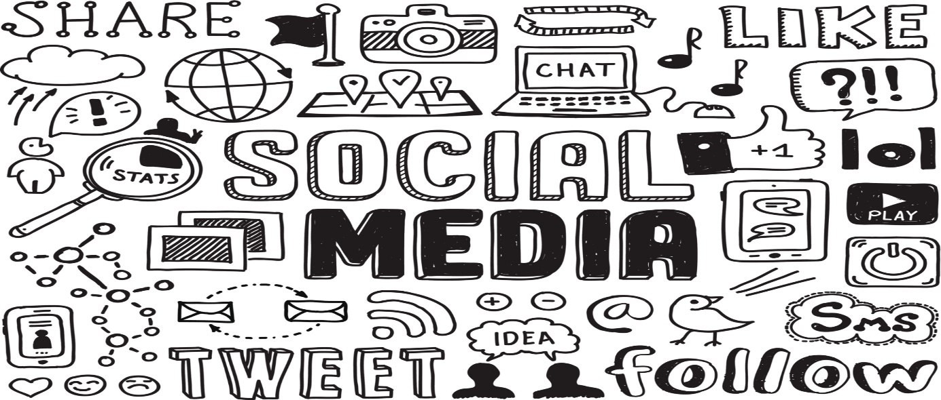
"Social Media." Digital image. 51a26c25a7e1f5afe9fa7be6e0bb898f.jpg. Accessed November 13, 2019. https://www.xactlydesign.com/wp-content/uploads/2017/02/51a26c25a7e1f5afe9fa7be6e0bb898f.jpg
Social Media is a wonderful way to connect with others: your peers, those in your local community, and in the larger global community. It can be used in positive ways to develop your social network. EVERYONE (who chooses to participate) has a voice on social media. However, having so much information can create confusion, and interacting online can have negative health impacts. Your assignment for Digital Learning is to consider the 3 resources below, link them together, make a creative piece to show your understanding of the questions, and share on your Edublog.
Step 1: Consider the following information:
Section 1: Read this article: https://bit.ly/2HXNOzh

Section 2: Watch this clip: https://bit.ly/2unykti

Section 3: Consider this future: https://tinyurl.com/ugo9xgn 1:27 and https://tinyurl.com/y7y9b3zg 1:17
Step 2: Linking the ideas together (think about these questions as you view):
Section 1: Article - Confusion is the point
- How have social media platforms changed the way we consume and understand information? 3-5 sentences

Section 2: Ted Talk - Is Social Media Hurting Your Mental Health?
- What value do you get from online social interactions? 3-5 sentences
- How is social media and social capital helping to form youth culture? 3-5 sentences

Section 3: Black Mirror: Nose Dive Clips
- Do you see any similarities between the world presented in this video and the world you live in? 3-5 sentences
- How does the main character gain and lose points? Why are these points important to her? What value might be derived from this type of social interaction? 3-5 sentences
- How are social interactions changed in the world of these clip? 3-5 sentences

Step 3: Make a creative piece to show the connections you made. You choose the format.
Make a Powtoon, Canva, Powerpoint, Google Slideshow, video uploaded to Stream, or another creative product to show your understanding for the questions in Step 2.
Step 4: Share your work via Edublogs
Add a New Post Called Social Media and Me and share your media. Please tag as Assignment2.
Deadline: JANUARY 24, 2019 12:30pm, AFTER THE ASSEMBLY FROM 10:30-11:30AM.
****Ms. Nagra and Mr. Valente are available for Flex support on Tuesdays and Thursdays to assist you with this assignment. We will be available from 11:30am to 12:30pm in the Drama room for support to finish off your assignment.***
In this rubric, please indicate the mark you think you earned, based on your work and understanding of the assignment.

Huh? Where is it?  Just starting out… (0)  In Progress (1)  Provide evidence below | OK, you did it, but you missed some details  Getting there (2) | Wow! You know what you’re doing!  2+ -> 3
DL Reflection (out of 9 marks):
Creativity Fluency
What type of creative piece did you create and why?
Media Fluency
Were you able to successfully add a new post to your Edublog entitled Social Media and Me?
Information Fluency
Did you convey your understanding of the volume and accuracy of information available through social media?
 | Total mark | /9

Choose 1 Critical Thinking Core Competency to reflect upon these questions and share your answers below:
Question and Investigate
How did you tell the difference between facts and interpretations, opinions and judgements?

Analyze and Critique
How did you analyze evidence from different perspectives?

For Ms. Nagra/Mr. Valente to write in this spot: What did we notice?

“Nosedive” is both dystopian fiction and acute social satire. Lacie (Bryce Dallas Howard) lives in a version of America where every tiny interaction is ranked by the people involved on an app that syncs with augmented-reality contact lenses (or retinal implants, it’s unclear). The minute you see someone you can also see their ranking, meaning that reality has morphed into a pastel-colored nightmare of aggressive cheeriness, as citizens attempt to out-nice each other and bump up their ratings. (from: https://www.theatlantic.com/entertainment/archive/2016/10/black-mirror-nosedive-review-season-three-netflix/504668/)

