ASSIGNMENT 1: HOW TO SET UP
YOUR EDUBLOG
This assignment is designed to get you started in DL 10.
The blog is an essential piece to sharing your learning publicly.
D
I
G
I
T
A
L

L
E
A
R
N
I
N
G

1
0
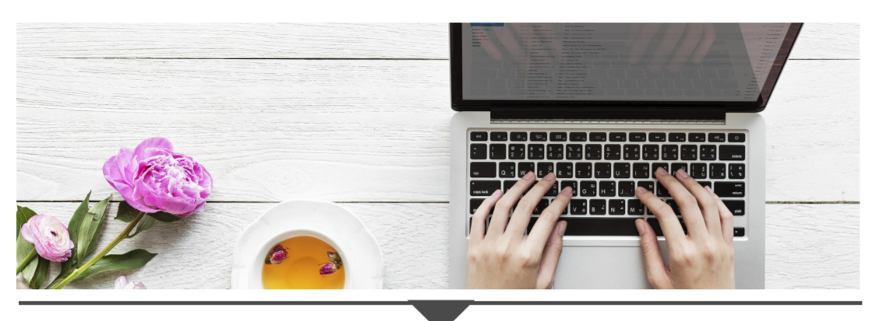

Step 1: Access your Edublog account
- Follow the directions in the Edublogs manual and teacher-led lesson to help you access your account.
- You can log-on direct at pmss.sd43.bc.ca using your username (firstnamelastnameinitial2020) and password (same as O365 password.)

Step 2: Customize your blog if you wish
- You can leave the pre-set Plane them and skip to step 3, or you can select another theme and update your header.
**Please make sure you update the menu if you change your theme so that we can see it.**

Step 3: Update your first page
- On the “About me” page, please introduce yourself. Only share what you feel comfortable with and make sure you do not share any identifiable information such as your full name or where you live.

Step 4: Create your first blog posts
- You will create 1 blog post for each of the following (3 blogs posts in total):
- Favourite YouTube clip
- Image of impact
- Meaningful quote
- Tag each post with #assignment1

Assessment
In this task, you will be creating original content on your new blog!
- Deadline: October 30, 2020
- Please do your self-assessment by highlighting where you are on the rubric and share what you want us to notice. Then, submit your assignment via Teams.
- Add your blog URL here: ______________________________________
- The fluencies or big ideas we will be assessing for this assignment are Media and Creativity:
Media - Be able to interpret and analyze media in order to both decode messages and create original content.
Creativity - Identify problems, develop, and generate ideas in new and imaginative ways to demonstrate learning.

RUBRIC - Self and Teacher Assessment
You must complete all the criteria from “Getting there,” “You did it” and “Wow” to achieve a 3/3.

Criteria from the Curricular Competencies | “Getting there...”  Criteria for 1/3 | “You did it!”  Meeting Expectations  Criteria for 2/3 | “Wow!!!”  Exceeding Expectations Criteria for 3/3
Creation (Create and express ideas through digital content for a specific audience) | - I added appropriate and relevant titles for each of my 3 posts. | - I have included an image (creative commons or included a link if not) and video as part of my posts.  - I have tagged all 3 posts with #assignment1. | - I have correctly cited all sources and images used (links or APA, if you know it).  - I cited myself if I am the originator of the content (e.g. I used a photo I took.)
Creation (Understand and implement principles of design to improve visual presentation.) | - I have included sufficient information (3-5 sentences) on my “About me” page to make the page visually inviting. | - The digital content (images and video) I selected for my 3 posts elevate my blog. | - I have embedded my video in my video post to enhance my blog’s overall esthetic.
Communication (Appropriately express information, experiences, and ideas through various digital tools.) | - I edited my Edublog’s “About me Page.”  - I created 3 new posts. | - I wrote a paragraph (3-5 sentences) to thoughtfully introduce myself on my “About me” page. | - I provided thoughtful insight (3-5 sentences) for each post to share why the posts are meaningful to me and show who I am as a person.
 | Total |  | /9

What do you want your teacher to notice about your assignment?

Here is what your teacher noticed:

