ASSIGNMENT 1: HOW TO SET UP
YOUR EDUBLOG
This assignment is designed to get you started in DL 10.
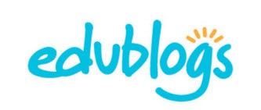
The blog is an essential piece to sharing your learning publicly.
D
I
G
I
T
A
L

L
E
A
R
N
I
N
G

1
0
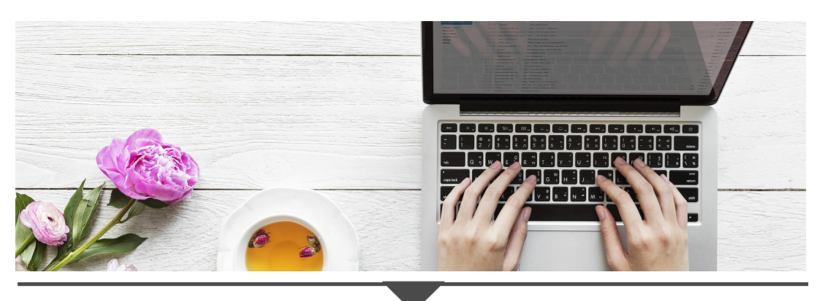

- Access your Edublog account
- Edublogs Manual Steps 2 - 3
- Log-on direct at pmss.sd43.bc.ca using your network username (088-firstinitiallastname) and password.

- Create your first page
- Edublogs Manual Steps 5 - 8
- On the “About me” page, write a paragraph to introduce yourself. Only share what you feel comfortable with and make sure you do not share any identifiable information such as your full name or where you live.

3. Create your first blog posts
- Edublogs Manual Steps 9 - 10
- You will create 1 blog post for each of the following (3 blogs posts in total):
- Favourite YouTube clip (School appropriate)
- Image of impact (Favourite picture)
- Meaningful quote
- For each post:
  - Explain (3-5 sentences minimum) why you selected these posts, how they are meaningful to you and how they show who you are as a person
  - Cite the source of the media (include links, APA, or indicate that you are the originator)
  - Tag each post with #assignment1

- Customize your blog (optional)
- Edublogs Manual Steps 11 - 15
- Select another theme and update your header.
**Please make sure you update the menu if you change your theme so that we can see it.**

Assessment
In this task, you will be creating original content on your new blog!
- Deadline: Friday, October 8, 2021
- Please do your self-assessment by highlighting where you are on the rubric and share what you want us to notice. Then, submit your assignment via Teams.
- Upload your blog URL by clicking add work -> click link ->insert URL in web address-> attach
- The fluencies or big ideas we will be assessing for this assignment are Media and Creativity:
Media - Be able to interpret and analyze media in order to both decode messages and create original content.
Creativity - Identify problems, develop, and generate ideas in new and imaginative ways to demonstrate learning.

RUBRIC - Self and Teacher Assessment
You must complete all the criteria from “Getting there,” “You did it” and “Wow” to achieve a 3/3.

Criteria from the Curricular Competencies | “Getting there...”  Criteria for 1/3 | “You did it!”  Meeting Expectations  Criteria for 2/3 | “Wow!!!”  Exceeding Expectations Criteria for 3/3
Creation (Create and express ideas through digital content for a specific audience.) | - I added appropriate and relevant titles for each of my 3 posts. | - I have included an image (creative commons) and video as part of my posts.  - I have tagged all 3 posts with #assignment1. | - I have correctly cited all sources and images used (links or APA, if you know it).  - I cited myself if I am the originator of the content (e.g. I used a photo I took.)
Creation (Understand and implement principles of design to improve visual presentation.) | - I have included sufficient information on my “About me” page to make the page visually inviting. (minimum 3-5 sentences) | - The digital content (images and video) I selected for my 3 posts elevate my blog. | - I have embedded a video in “My favourite Youtube post” to enhance my blog’s overall esthetic.
Communication (Appropriately express information, experiences, and ideas through various digital tools.) | - I edited my Edublog’s “About me Page.”  - I created 3 new posts. | - “About me page” thoughtfully introduces myself without specific identifiable information.  (minimum 3-5 sentences) | - I provided thoughtful insight (minimum 3-5 sentences) for each post to share why the posts are meaningful to me and show who I am as a person.
 | Total |  | /9

What do you want your teacher to notice about your assignment?

Here is what your teacher noticed:

