ASSIGNMENT 1: HOW TO SET UP YOUR EDUBLOG
D
I
G
I
T
A
L

L
E
A
R
N
I
N
G

1
0
This assignment is designed to get you started in DL 10.
The blog is an essential piece to sharing your learning publicly.

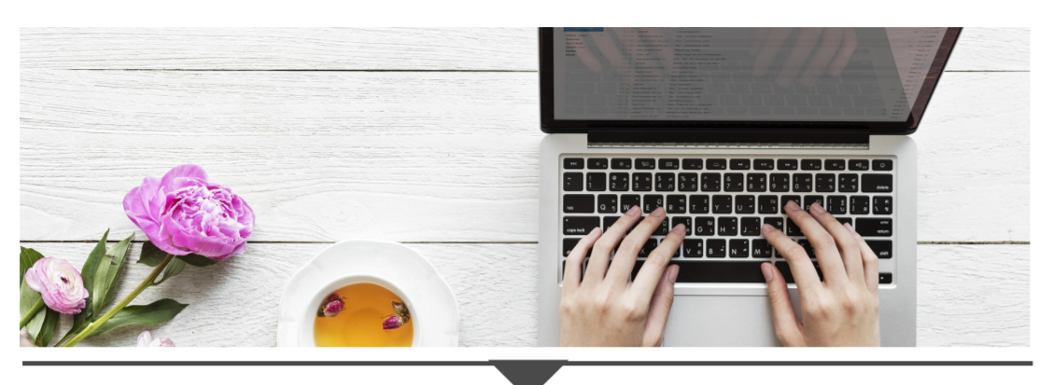

- Access and create your Edublog account
- Edublogs Manual Steps 1 - 7
- Log-in direct at pmss.sd43.bc.ca

2. Create your first blog posts
- Edublogs Manual Steps 8 - 9
- You will create 1 blog post for each of the following (3 blogs posts in total):
- Meaningful quote
- Image of impact (Favourite picture)
- Favourite YouTube clip (School appropriate, 5 mins max)
- For each post:
  - Explain (3-5 sentences) why you selected these posts, how they are meaningful to you, and how they show who you are as a person.
  - Cite the source of the media (include links or indicate that you are the originator)
  - Tag each post with #assignment1

3. Create your About Me page
- Edublogs Manual Steps 10 - 12
- On the “About Me” page, write a paragraph to introduce yourself. Only share what you feel comfortable with and make sure you do not share any identifiable information. Do not include your last name and where you live.

- Customize your blog
- Edublogs Manual Steps 13 – 18
- Change your site’s name
- Additional customizations (optional):
Select another theme and update your header.
**Please make sure you update the menu if you change your theme so that we can see it.**

Assessment
The big ideas we will be assessing for this assignment are Media and Creativity:
Media - Be able to interpret and analyze media to both decode messages and create original content.
Creativity - Identify problems, develop, and generate ideas in new and imaginative ways to demonstrate learning.

Deadline: Wednesday October 4, 2023
You will turn-in 2 items through Teams:
- Self assessment - highlight where you are on the rubric below and share what you want us to notice. Submit your self-assessment via Teams.
- Attach your blog’s public URL by clicking Attach -> Link -> Insert URL in web address-> Attach

RUBRIC - Self and Teacher Assessment

You must complete all the criteria from “Getting there,” “You did it” and “Wow” to achieve a 3/3. Reminder to use the checklist to help you too 😊

Criteria from the Curricular Competencies | Emerging  Criteria for 1/3 | Developing  Criteria for 2/3 | Proficient  Criteria for 3/3
Creation (Create and express ideas through digital content for a specific audience.) | - I added appropriate and relevant titles for each of my 3 posts. | - I included an image (creative commons) and video as part of my posts.  - I tagged all 3 posts with #assignment1.  - I added links to my sources for photos. | - I cited all sources and images.  - I cited myself if I am the originator of the content (e.g. I used a photo I took.)
Creation (Understand and implement principles of design to improve visual presentation.) | - I included sufficient information on my “About Me” page to make the page visually inviting (minimum 3-5 sentences). | - The digital content (images and video) I selected for my 3 posts elevates my blog. | - I embedded a video in “My favourite YouTube” post to enhance my blog’s overall esthetic.
Communication (Appropriately express information, experiences, and ideas through various digital tools.) | - I edited my Edublog’s “About me Page.”  - I created 3 new posts.  - I changed my blog site’s name.  - Completed the self-assessment | - “About Me” page thoughtfully introduces myself without specific identifiable information.  (minimum 3-5 sentences) | - I provided thoughtful insight (minimum 3-5 sentences) for each post to share why the posts are meaningful to me and show who I am as a person.
 | Total |  | /9

What do you want your teacher to notice about your assignment?

Here is what your teacher noticed:

