Assignment 2: Digital Footprint

The goal of this assignment is for you to reflect on your digital footprint.
You will describe the key messages around digital footprints and discuss how your digital footprint can impact your brand/who you are.
D
I
G
I
T
A
L

L
E
A
R
N
I
N
G

1
0

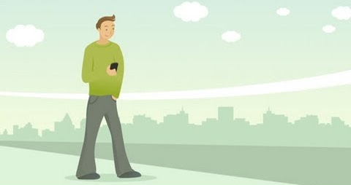
- Watch the following videos:
(4:52 mins): “Live My Digital for students: Digital Footprint”  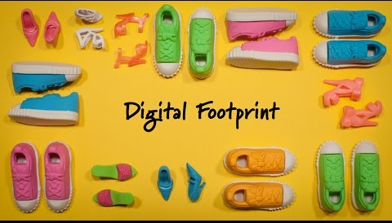 | (1:40 mins) Sharing Information: A Day in Your Life

- Answer the questions below in a new Edublog post.
You will present your finalized thoughts in a powerful format - examples: a video, slideshow, poster, infographic in your post. You will need to do some additional research to answer the questions.
Questions to Answer

A. Your Digital Footprint. Google yourself. Picture how your footprint comes across to others.
  - How might your digital footprint affect your personal brand and future (e.g. school and work) opportunities? Give at least two examples.
  - Think about the digital services you use daily. What information have you unintentionally shared? Who has this information, and where could it be going next?
B. Safety.
    - Describe at least three strategies that you can use to keep your digital footprint appropriate and safe.
C. Digital Permanence.
    - What is digital permanence?
    - Why should we care and be aware of “digital permanence?”

3. Your Blog Post
1) Select a response format from the following options:
  - Video (maximum 2 minutes in length) (e.g. PowToon); embed in a new post (minimum 3 visuals).
  - Infographic or visual presentation with both text and graphics (e.g. Canva); embed in a new post (minimum 3 visuals).
  - Slideshow (e.g. PowerPoint, Sway, or Google Slides); embed in a new post (minimum 3 visuals).
  - Talk to your DL teacher if you have another idea.
- Effectively answer ALL questions (in blue above) in your presentation.
- Share your response in a new post called: My Digital Footprint.
- Add a tag: #Assignment2
- Copy and Paste a link to your Edublog page onto the assignments tab and hit Turn In.
- Complete self-assessment and attach on Teams.

Due Date: December 6th, 2023

Your response must be uploaded to your Edublog account by the end of school day on December 6th. If there is any evidence of plagiarism, your response will be considered incomplete, and you will redo your assignment.
Helpful Resources
- Student examples (students who have gone above and beyond, yours does not have to be as exceptional as this, as long as it follows the rubric)
Create a website: https://tinyurl.com/y56f49ej
Create an infographic: Digital Footprint / Lena (sd43.bc.ca)
Create a slideshow: My Digital Footprint – Andrea’s Blog (sd43.bc.ca)

- How to Reference: https://tinyurl.com/ew7y2a5c
AI-Generated Content and Citation

- Useful “How To…” videos How to videos… – (sd43.bc.ca)
RUBRIC - Self and Teacher Assessment
You must complete all the criteria in every column to achieve a 3/3.
Ensure that you complete the Emerging column before moving on to Developing, then Proficient.

Curricular  Competencies | Emerging  1/3 | Developing  2/3 | Proficient  3/3
Critical Consumption | - Used the information in the videos to support my answer | - Researched and cited additional sources to support my responses  - All information is written in my own words or appropriately quoted | - Highlighted the importance of online safety and how it connects to a digital footprint  - Integrated additional researched information from multiple sources into my responses
Creation | - Used an appropriate medium from the presentation tools listed  - Embedded my presentation in my post  - Tagged my post with #Assignment2 using the Edublog tagging feature | - Included at least 3 appropriate visuals from credible sources  - Gave credit to the author/owner of the images by providing links for the sources and photos | - Used APA citations to reference provided videos and all additionally researched information  - Presentation is visually appealing, unique, creative
Communication | - Answered all the questions in a new post titled: My Digital Footprint  - Completed self-assessment | - Visuals help effectively communicate and enhance my message | - Included thoughtful information and personal examples from reputable sources to help me insightfully answer all the questions  - Written responses adhere to conventions of writing (spelling, grammar, etc.)
 | Total |  | /9

What do you want your teacher to notice about your assignment?

Here is what your teacher noticed:

