Digital Learning 10 2023-2024

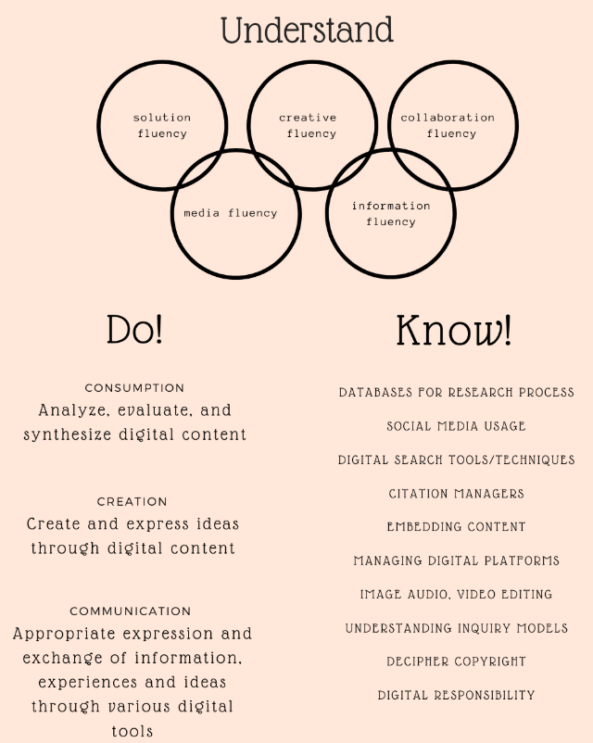
Applications of Digital Learning (DL) 10 is a full-year online course that is taken by all Grade 9s. This course includes key learning assignments that will be shared during virtual assemblies and class meetings.

The goals of DL 10 include learning to
- choose the correct digital tool for the right purpose
- create and share a digital product with a specific audience
- behave ethically and responsibly online
- protect the privacy and security of themselves and others.

The Curriculum and Course Learning
Consumption, communication, and creation are central themes of the course.

Course Expectations
- Students who are not meeting the learning outcomes of the course may receive an “Insufficient Evidence” mark. This “IE” status may be shared with counsellors, vice-principals, parent/guardian via a report, phone call or email.
- A failing grade will be assigned if work has not been completed by a set date to show sufficient evidence of the learning outcomes of the course.
- Assemblies and course lesson meetings are mandatory. Attendance will be taken.
- Assignments must be the work of the student who submits it. Academic dishonesty will be reported to the school administration and students involved will have to engage in restorative behaviour.

Course Assessment and Evaluation
- Key learning assignments will be delivered through Teams meetings
- Individual teacher support is available digitally (via Teams) and in-person (Flex learning time). Contact your teacher with questions as needed.
- Opportunities for students to self-assess and reflect on their growth in the core competencies will be embedded throughout the course.

Key Topics & Learning Assignments | Percentage of course grade
Who am I?  Assignment 1: Edublogs Set-up Assignment | 10%
Who am I online?  Assignment 2: My Digital Footprint  Assignment 3: Social Media and Me | 30%  30%
Who am I as a learner?  Assignment 4: My Digital Portfolio | 30%
Reflections and self-assessment of growth in the core competencies. | Feedback provided throughout the year.
Percentage | Letter Grade | Progress
86%-100% | A | Excellent
73% - 85% | B | Very Good
67% - 72% | C+ | Satisfactory
60% - 66% | C | Satisfactory
50% - 59% | C- | Satisfactory
0% - 49% | F | Failing Grade
- | IE | Insufficient Evidence

Contact Us!
Since this course is not delivered by direct in-class instruction, individual teacher support is available digitally by contacting your DL teacher and in-person by appointment during Flex learning time. Stay informed of class meetings, virtual assemblies, and due dates by downloading the My School Day app and subscribing to the Digital Learning channel for announcements, reviewing the PMSS Times announcements for details and by checking Teams regularly. Additional and on-going learning support and information is also available digitally via the PMSS Edublog site.

Marina Mehai mmehai@sd43.bc.ca
Brandon Tuason btuason@sd43.bc.ca
Angela Chan achan@sd43.bc.ca
Giovanni Valente gvalente@sd43.bc.ca
Course Information
Edublogs: http://pmss.sd43.bc.ca/ | 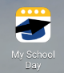  School App:  Download and subscribe  to the DL channel. | 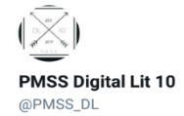  Twitter: https://twitter.com/pmss_dl

