-Slam poetry
I choose this achievement because I was able to put the thoughts in my head on to paper and it made sense. It also gave me a ton of confidence to try other English assignments. It made me feel that I could get a good mark on other projects that would be given to me. Getting started was hard. Finding a topic that was important to me and be understandable. to others. 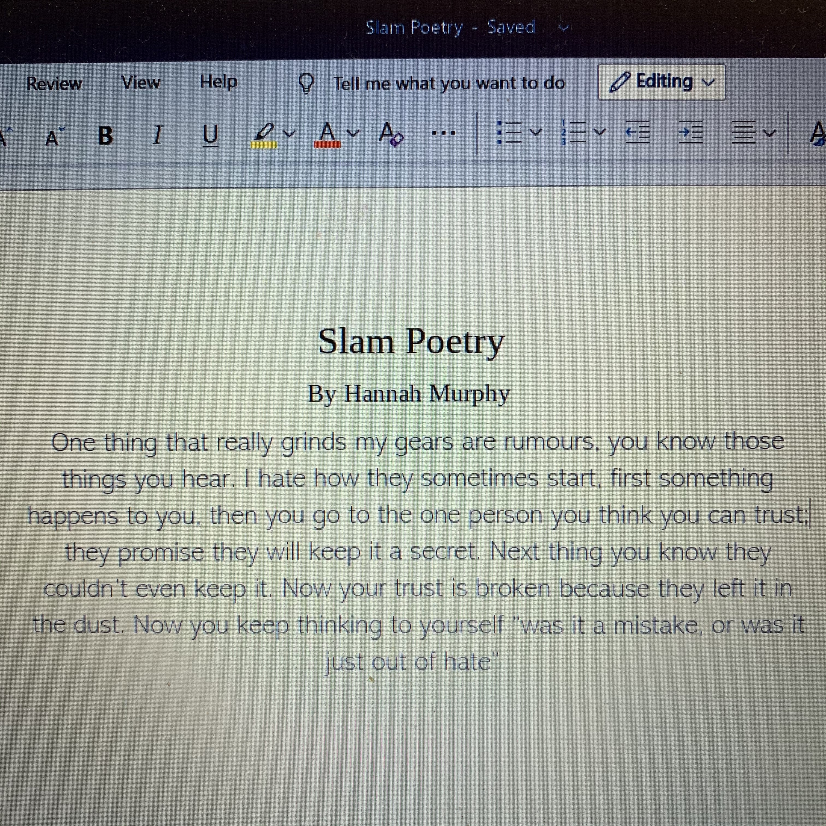
- B In math
I was very proud when I saw I got a B on my midterm report card. It took a lot of hard work I attended Math tutor at Mathnasium 6 days a week. I also attended flex as much as I could for extra help. I have never gotten a B in math before even in previous grades, it inspires me to work even harder and shoot for an A. In the future I am much more confident to ask for help when I need it.
I've learned it’s very important how I ask for help is just as important. I try to be specific in what I need. I need to work it out myself as much as possible instead of saying ‘I don’t get it.’ This helps the tutors realize where I am stuck. They tell me this is a good life lesion to always talk it out.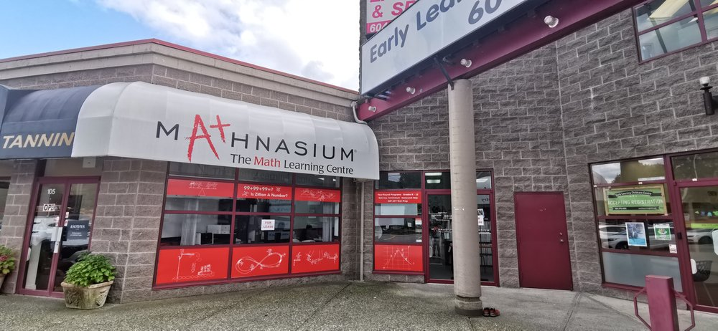
-French
I hated walking into my French class with a dozen of I.B students who could speak French fluently. It intimated me. For me it was a good day if I could make it to the car holding back tears. Once school went into lockdown, I didn’t get very far with my French I didn’t focus on it as much as I should have been. Even though I did not like French I always wanted to get better to prove to myself that I can do it and I wasn’t a looser. I picked up my phone and used this French learning app called Duolingo. When I am watching Netflix, I would turn French subtitles on and even that helped a bit. I knew that every little thing counts. A huge challenge for me was believing in myself and not letting the pressure get to me.
