My digital footprint
https://blog.goennounce.com/what-you-do-online-has-consequences-heres-how-to-create-a-positive-digital-footprint/

I googled myself on the internet. and there are quite many things about me. such as some price ai got and the things I wrote.
In my own opinion.I think my own digital footprint is going to affect our future. for example, if someone do not have a good impression on the internet. when the university they wanna go to google their information online. they are not going to allowed to going to that university they wanna going to. digital footprint is a thing you cant erased. Your future employee would also be effected the same way as your university. It is important to start being aware of what you post online now. For this could have heavy impact on your future.
Use respectful languages on the internet, and respect everyone. For this way it wouldn’t affect your online personality.
http://meihongz-session-1.blogspot.com/2014/09/what-is-digital-footprint-digital.html
Don't go on inappropriate websites for your age. It might affect your growth.
Try to keep a clean shat history on social media. Even if they are your close friends. For this will help you keep your position online safe.
Digital permanence is like a wooden board. When you scratch it with a nail. The scratch will fade but never disappear. It's going to be part of that board forever. This is like digital permanence. It will stay with you your entire life.
That’s all of my opinion.thankyou.
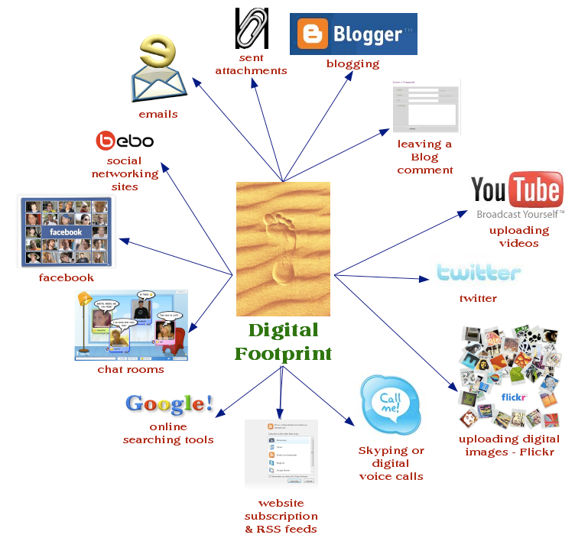
meihongz-session-1.blogspot.com/2014/09/what-is-digital-footprint-digital.html

